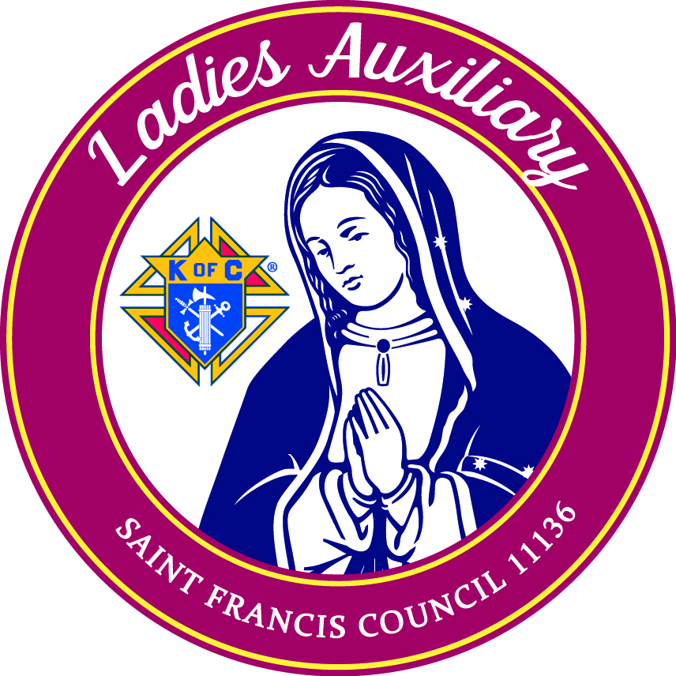
Ladies Auxiliary Saint Francis Council 11136
Membership Form

Last Name: | First Name: | Middle Initial:
Street/Apt. #: | City: | State: | Zip Code:
E-mail Address: | Mobile Phone: | Home Phone:
Occupation: | Date of Birth: (can be month/date) | Marital Status:
What talents or gifts can you offer the Ladies Auxiliary? Ex: time, sales expertise, marketing expertise, able to volunteer, able to cook, sew, drive to deliver meals, help with kid activities, etc.
Is your marriage recognized as valid by the Catholic Church? |  | Yes | No
Are you a PRACTICAL or PRACTICING Catholic in union with the Holy See? |  | Yes | No
Parish Name: | City: | State:
Have you applied for Membership previously? |  | Yes | No
I hereby recommend the above applicant for membership.
Printed Name of Proposer:
Signature of Applicant:
Signature of President: |  | Date
Signature of Treasurer: |  | Date Dues Paid

Membership in the Ladies Auxiliary is open to women 18 years or older who are practicing Catholics in union with the Holy See. This means that an applicant or member accepts the teaching authority of the Catholic Church on matters of faith and morals, aspires to live in accord with the precepts of the Catholic Church, and is in good standing in the Catholic Church.

Please return this Membership Form to the church office or scan and email ladiesaux11136@gmail.com. Membership dues of $25 per year can be brought to our monthly business meetings. Dues will be prorated as necessary.

