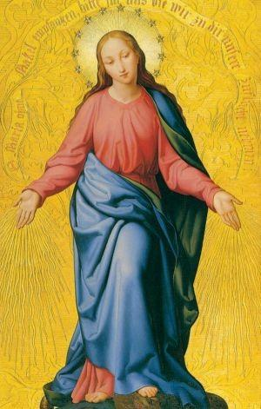
Consecrate Yourself to Jesus
through Mary

Join us for a 6 week small-group retreat in preparation for Marian Consecration. This retreat is based on the popular book by Fr. Michael Gaitley, MIC, 33 Days to Morning Glory.
Gain new insights into Marian Consecration, learn how key saints and blessed lived it out, and how you can live it out as well.
MEN & WOMEN CAN JOIN!

Classes will be on Wednesdays at 7:00 p.m. in room 202 of the Religious Education Center; beginning February 19th; consecration ceremony on Saturday, March 28th
in celebration of the Annunciation.

For questions or registration email: ladiesaux11136@gmail.com.

